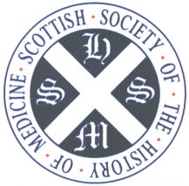
Scottish Society of the History of Medicine
Scottish Charity No: SC008621

Application form for membership

Name: ……………………………………………………………………….

Title: ……………………….(Dr, Mr, Mrs, Miss, Professor or other)

Address: …………………………………………………………………….
…………………………………………………………………….
…………………………………………………………………….

Post Code: ………………………………..
Telephone: ………………………………..
E-mail: ……………………………………

The annual subscription is £15 which is normally paid by Banker’s Order (enclosed/attached). Please send the completed application form to the SSHM Secretary, Mr Andreas Demetriades, 2 Belmont Terrace, Edinburgh EH12 6JF.

